<<Report>>
Experimental(1)

(1)EXPERIMENT NAME: Operations on Sets
(2)Experiment using software:COMPILER>>VISUAL STUDIO(2019)
(3)Program design:C++
(4)Running result:after intput
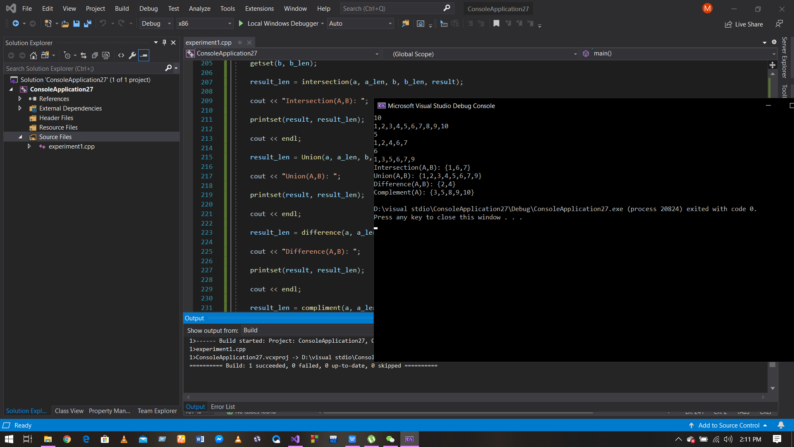
Intersection(A,B): {1,6,7}
Union(A,B): {1,2,3,4,5,6,7,9}
Difference(A,B): {2,4}
Complement(A): {3,5,8,9,10}

- Comments:
(#) No problems.The difficulty level is fine
(#) It helped me to look at relations from a computer science perspective.
(#) More problems should be solved by programming..
<<<<<<<<<<<<<<<<END>>>>>>>>>>>>>>>

